1 run...

Downloading: 100%

411/411 [00:00<00:00, 14.9kB/s]

Downloading: 100%

263M/263M [00:11<00:00, 23.9MB/s]

training 1 epoch...

1558.8306965827942 seconds used......

1 training finished! average train loss: 1.141379392882054

total clf loss: 1141.9859506338835 total adv loss: 442.55192625150084

evaluating...

Confusion matrix, without normalization

[[2409 0 131]

[ 233 0 54]

[ 599 0 1272]]

Normalized confusion matrix

[[0.9484252 0. 0.0515748 ]

[0.81184669 0. 0.18815331]

[0.32014965 0. 0.67985035]]

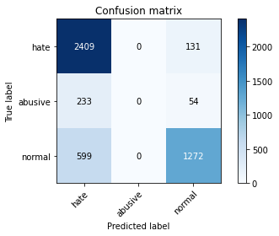

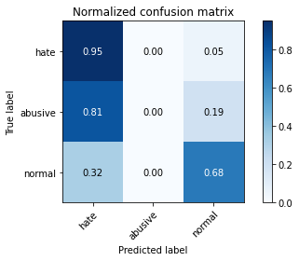

/opt/conda/lib/python3.7/site-packages/sklearn/metrics/_classification.py:1245: UndefinedMetricWarning: Precision and F-score are ill-defined and being set to 0.0 in labels with no predicted samples. Use `zero_division` parameter to control this behavior.

_warn_prf(average, modifier, msg_start, len(result))

/opt/conda/lib/python3.7/site-packages/sklearn/metrics/_classification.py:1245: UndefinedMetricWarning: Precision and F-score are ill-defined and being set to 0.0 in labels with no predicted samples. Use `zero_division` parameter to control this behavior.

_warn_prf(average, modifier, msg_start, len(result))

/opt/conda/lib/python3.7/site-packages/sklearn/metrics/_classification.py:1245: UndefinedMetricWarning: Precision and F-score are ill-defined and being set to 0.0 in labels with no predicted samples. Use `zero_division` parameter to control this behavior.

_warn_prf(average, modifier, msg_start, len(result))

precision recall f1-score support

hate 0.74 0.95 0.83 2540

abusive 0.00 0.00 0.00 287

normal 0.87 0.68 0.76 1871

accuracy 0.78 4698

macro avg 0.54 0.54 0.53 4698

weighted avg 0.75 0.78 0.76 4698

average eval_loss: 0.5538227745193116, accuracy: 0.7835249042145593

training 2 epoch...

1557.8798623085022 seconds used......

2 training finished! average train loss: 0.9601077704044344

total clf loss: 911.8101417422295 total adv loss: 396.67062879540026

evaluating...

Confusion matrix, without normalization

[[2226 4 310]

[ 179 3 105]

[ 318 6 1547]]

Normalized confusion matrix

[[0.87637795 0.0015748 0.12204724]

[0.62369338 0.01045296 0.36585366]

[0.16996259 0.00320684 0.82683057]]

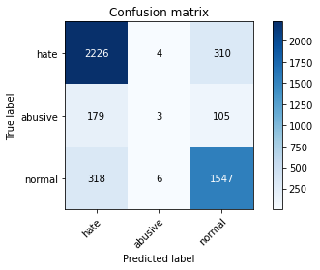

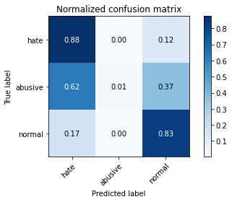

precision recall f1-score support

hate 0.82 0.88 0.85 2540

abusive 0.23 0.01 0.02 287

normal 0.79 0.83 0.81 1871

accuracy 0.80 4698

macro avg 0.61 0.57 0.56 4698

weighted avg 0.77 0.80 0.78 4698

average eval_loss: 0.5149025802282576, accuracy: 0.8037462750106428

training 3 epoch...

1558.053248167038 seconds used......

3 training finished! average train loss: 0.7411991873974199

total clf loss: 688.1672683060169 total adv loss: 314.1012441017665

evaluating...

Confusion matrix, without normalization

[[2168 91 281]

[ 142 44 101]

[ 266 86 1519]]

Normalized confusion matrix

[[0.85354331 0.03582677 0.11062992]

[0.49477352 0.1533101 0.35191638]

[0.14216996 0.04596472 0.81186531]]

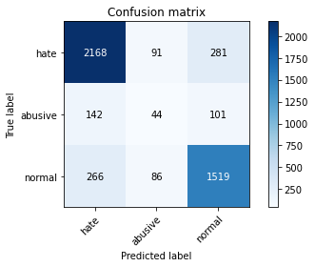

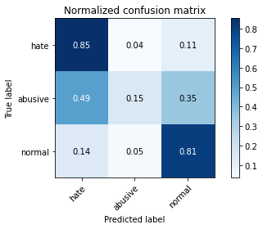

precision recall f1-score support

hate 0.84 0.85 0.85 2540

abusive 0.20 0.15 0.17 287

normal 0.80 0.81 0.81 1871

accuracy 0.79 4698

macro avg 0.61 0.61 0.61 4698

weighted avg 0.79 0.79 0.79 4698

average eval_loss: 0.6017945642801041, accuracy: 0.7941677309493401

training 4 epoch...

1558.177793264389 seconds used......

4 training finished! average train loss: 0.46418263514521996

total clf loss: 446.8652706556022 total adv loss: 188.76154450071044

evaluating...

Confusion matrix, without normalization

[[2258 42 240]

[ 167 19 101]

[ 375 49 1447]]

Normalized confusion matrix

[[0.88897638 0.01653543 0.09448819]

[0.58188153 0.06620209 0.35191638]

[0.20042758 0.0261892 0.77338322]]

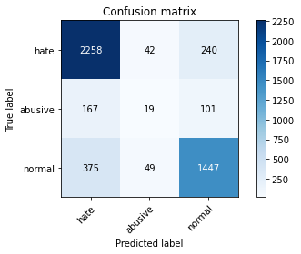

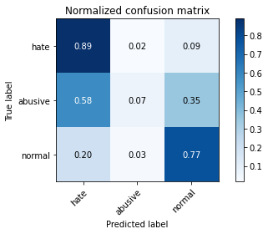

precision recall f1-score support

hate 0.81 0.89 0.85 2540

abusive 0.17 0.07 0.10 287

normal 0.81 0.77 0.79 1871

accuracy 0.79 4698

macro avg 0.60 0.58 0.58 4698

weighted avg 0.77 0.79 0.78 4698

average eval_loss: 0.7706068737075684, accuracy: 0.7926777352064709

training 5 epoch...

1558.522932767868 seconds used......

5 training finished! average train loss: 0.2494983647429271

total clf loss: 269.15229898598045 total adv loss: 86.9783983290381

evaluating...

Confusion matrix, without normalization

[[2219 79 242]

[ 166 26 95]

[ 379 82 1410]]

Normalized confusion matrix

[[0.87362205 0.03110236 0.09527559]

[0.57839721 0.09059233 0.33101045]

[0.20256547 0.04382683 0.7536077 ]]

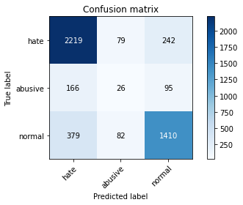

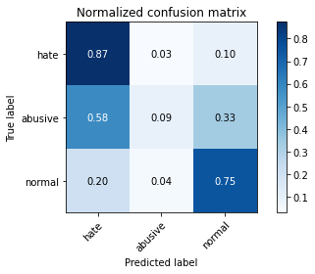

precision recall f1-score support

hate 0.80 0.87 0.84 2540

abusive 0.14 0.09 0.11 287

normal 0.81 0.75 0.78 1871

accuracy 0.78 4698

macro avg 0.58 0.57 0.58 4698

weighted avg 0.76 0.78 0.77 4698

average eval_loss: 0.8754512152931792, accuracy: 0.7779906343124734

training 6 epoch...

1558.9905643463135 seconds used......

6 training finished! average train loss: 0.16455756372031188

total clf loss: 180.4554123088019 total adv loss: 55.89941041288466

evaluating...

Confusion matrix, without normalization

[[2128 73 339]

[ 141 20 126]

[ 295 60 1516]]

Normalized confusion matrix

[[0.83779528 0.02874016 0.13346457]

[0.4912892 0.06968641 0.43902439]

[0.1576697 0.03206841 0.81026189]]

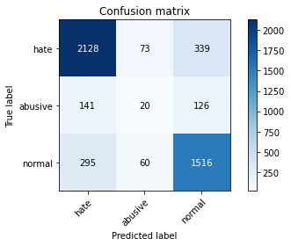

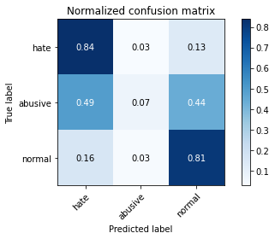

precision recall f1-score support

hate 0.83 0.84 0.83 2540

abusive 0.13 0.07 0.09 287

normal 0.77 0.81 0.79 1871

accuracy 0.78 4698

macro avg 0.58 0.57 0.57 4698

weighted avg 0.76 0.78 0.77 4698

average eval_loss: 1.065880489341439, accuracy: 0.779906343124734

training 7 epoch...

1558.8402156829834 seconds used......

7 training finished! average train loss: 0.12837694143728423

total clf loss: 137.2726741716615 total adv loss: 45.362387014688295

evaluating...

Confusion matrix, without normalization

[[2211 65 264]

[ 156 23 108]

[ 379 70 1422]]

Normalized confusion matrix

[[0.87047244 0.02559055 0.10393701]

[0.54355401 0.08013937 0.37630662]

[0.20256547 0.03741315 0.76002138]]

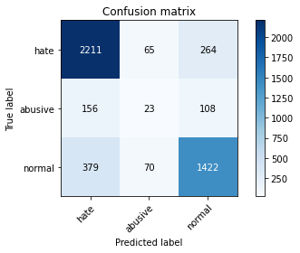

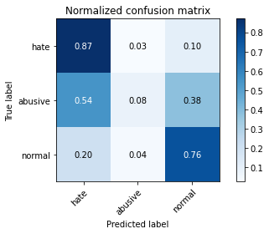

precision recall f1-score support

hate 0.81 0.87 0.84 2540

abusive 0.15 0.08 0.10 287

normal 0.79 0.76 0.78 1871

accuracy 0.78 4698

macro avg 0.58 0.57 0.57 4698

weighted avg 0.76 0.78 0.77 4698

average eval_loss: 1.1407130971233896, accuracy: 0.778203490847169

training 8 epoch...

add Codeadd Markdown